JavaScript Inline Code Step

Objective:

It is used to execute any custom external javascript code. Scripts are provided and executed as plain text. They don’t need special preparation or compilation to run. In this aspect, JavaScript is very different from another language called java.

## UI

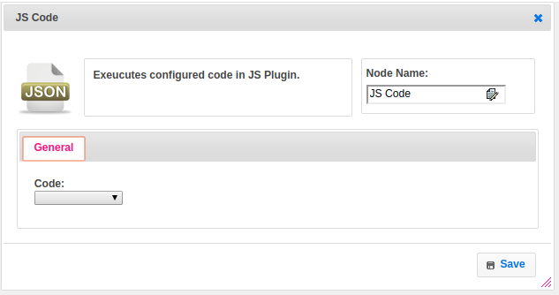

## Attributes:

|  |  |
| --- | --- |
| **Attributes** | **Description** |
| Code | The name of plugin which we have configured earlier with javascript code |

## Dependent plugins:

|  |  |
| --- | --- |
| Attributes | Description |
| Javascript Code | The code which we want to execute in javascript. Means declaring whole code in plugin and using this code in steps by calling the name of the plugin |

## Executor Description:

In executor class first will get plugin code through plugin handler. Function name is null or empty then get the function name. If returned value is not map then set that value to map , where the key name is function name.

## Resource:

For more information please refer the below link

<https://documentation.js.org/>